Item | Description | Picture
Easy Wave Petunias – Pink Passion – 6” pot | Fast-growing and are the most versatile for your garden. Grow them in the ground or in any basket or patio container. They tolerate the heat and cooler night conditions well. Exposure: Sun  Mature Plant Height: 6-12" Full Spread: 30-39"  Success Tips: Avoid wet foliage going into night. Keep well fed for best performance. Occasional cut back will rejuvenate plants. | 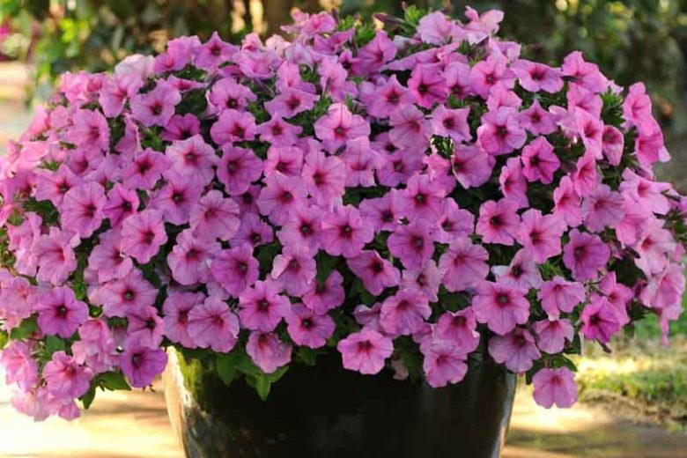
Easy Wave Petunias – Pum Vein (rich lavender base with darker veining radiating from its center. This two-tone quality helps it pair with other dark-hued flowers)  – 6” pot | Fast-growing and are the most versatile for your garden. Grow them in the ground or in any basket or patio container. They tolerate the heat and cooler night conditions well. Exposure: Sun  Mature Plant Height: 6-12" Full Spread: 30-39"  Success Tips: Avoid wet foliage going into night. Keep well fed for best performance. Occasional cut back will rejuvenate plants. | 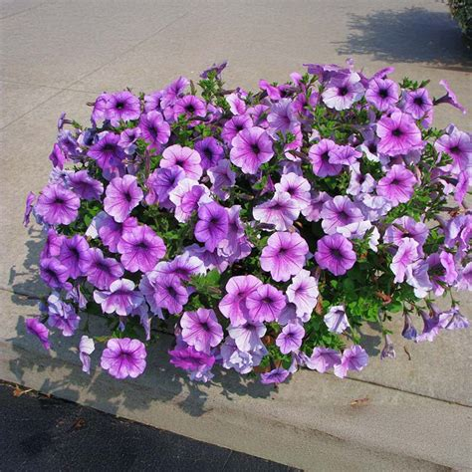
Graceful Grasses – King Tut: 6” pot | Large heads of pendulous leaves; greenish flower spikelets can measure 1' across. Garden Height: 48 - 72 Spread: 36 - 48 Inches. Part Sun to Sun  The optimum amount of sun or shade each plant needs to thrive: Full Sun (6+ hours), Part Sun (4-6 hours), Full Shade (up to 4 hours) | 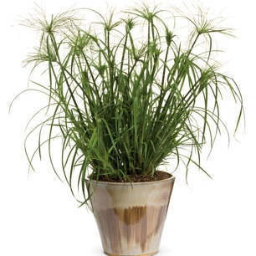
Zinnias – Dreamland Mix – good size – 3 per pack | Dreamland™ Mix Hybrid Zinnia is very rugged and weather tolerant, this sun-lover renews itself quickly after storms, thanks to waxy petals and a very tough, vigorous plant constitution. The luminous hues in this series blend harmoniously in the garden, and the flowers stay fresh for well over a week in the vase | 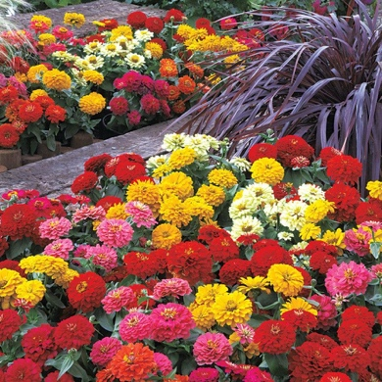
Alyssum – Carpet of Snow White – 6 pack | Alyssum Carpet of Snow is best placed in full sun to produce the best blooms. The plant will need shade protection from the intense afternoon sun in hotter areas. A spot providing at least six hours of morning sunlight daily is ideal. Low maintenance and easy to grow. Grows from 6 to 12 inches wide and tall | 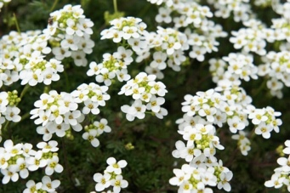
Lobella – Marine Blue - – 6 pack | Ball shaped plants stay compact and mounded throughout the season; interesting blue flowers blanket rich green foliage; a great selection for early flowering beds, borders and containers  Will grow to be only 5 inches tall at maturity, with a spread of 8 inches. This plant should be grown in a location with partial shade or which is shaded from the hot afternoon sun | 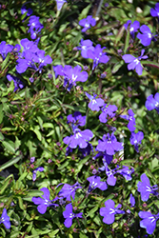
Snap Dragon – Dwarf Mixed - – 6 pack | Classic cottage garden favorites, the long-blooming plants flower for months in charming large, tubular, two-lipped flowers in eye-catching colors. Borne in terminal racemes on erect spikes, the nectar-filled flowers emit a fragrance, attract bumble bees and hummingbirds, and make excellent cut flowers. The herbaceous plants have a bushy, upright, mounding habit, only growing about 6 to 8 inches high and wide. | 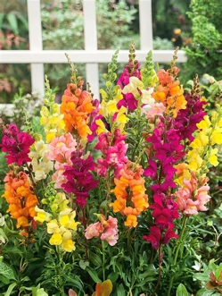
Snap Dragon – Dwarf Red - – 6 pack | Classic cottage garden favorites, the long-blooming plants flower for months in charming large, tubular, two-lipped flowers in eye-catching colors. Borne in terminal racemes on erect spikes, the nectar-filled flowers emit a fragrance, attract bumble bees and hummingbirds, and make excellent cut flowers. The herbaceous plants have a bushy, upright, mounding habit, only growing about 6 to 8 inches high and wide. | 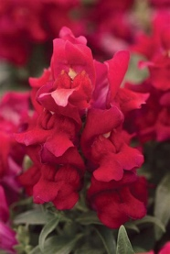
Snap Dragon – Rocket Red - 6 pack | This outstanding heat tolerant strain has been a grower favorite for years. A super garden performer, the plants produce tall spikes that display bright, closely set florets on sturdy stems. Used frequently for field grown cut flowers – Spacing: 14 - 18 Height: 30 - 36" Width: 16 - 18" | 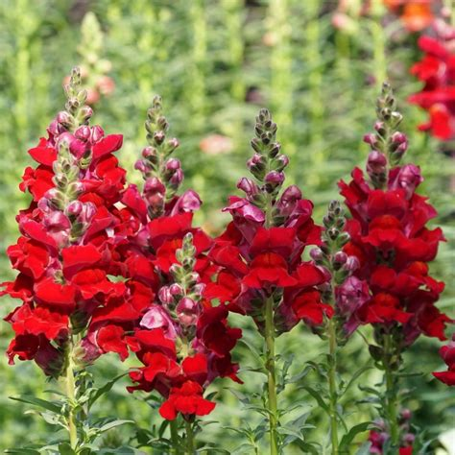
Verbena Mixed - 6 pack | Extremely long blooming and heavy flowering, with the strongest bloom in spring, this mix includes a wide range of colors: pink, purple, red, rose, and white. - performs well in hot, dry conditions and makes an excellent ground cover.  Height 8-16” | 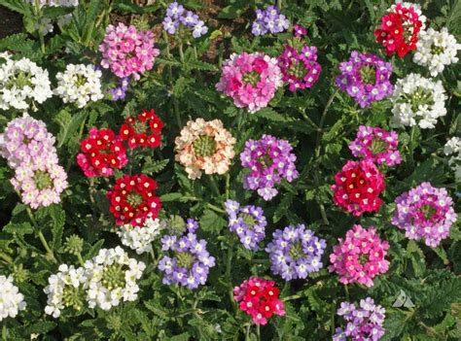
Dusty Miller – Silver Dust - 6 pack | Dusty Miller's silvery foliage is now a very popular cut-flower filler for elegant bouquets. Silverdust has large, 3-7" long, velvety leaves with a magical snowflake appearance. Full sun  Space 9-12” | 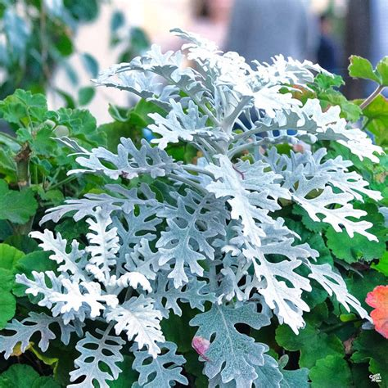
Dwarf Marigold – hot Pak Mix - 6 pack | Developed in the heat for the heat, extra dwarf plants stay compact, proudly displaying loads of 1-3/4 to 2" blooms, without stretching or falling open. A mix of Gold, Flame, Harmony, Fire, Orange, Spry and Yellow.  Full sun, Spreads 6 to 8". Ht: 6-7". | 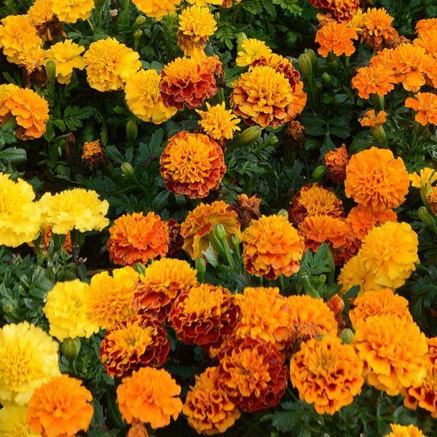
Dwarf Marigold – Medium large flower – Taishan Mix - 6 pack | The most exceptional branching dwarf marigold available on the market. Lush plants that perform better and last longer. This is a very good landscape plant with high-impact colors  Full Sun, Part Sun Height: 14-16 inches  Spread: 8-10 inches | 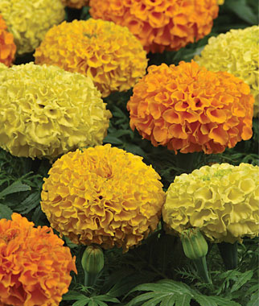
Wax Begonia – dark leaf mix - 6 pack | Wax begonia is a compact, mounded, succulent and fibrous-rooted plant with fleshy stems and dark green leaves. Generally requiring little maintenance, plants mature in size to around 6 to 12 inches high with a similar spread. Once established, wax begonias adapt to a wide range of light conditions. Color of flower may be different from picture | 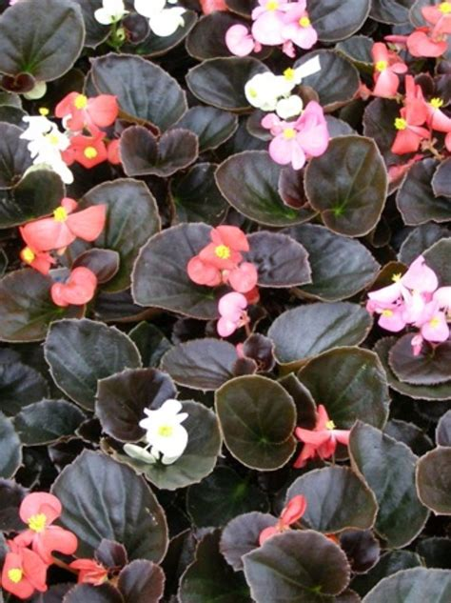
Wax Begonia – green leaf mix - 6 pack | Wax begonia is a compact, mounded, succulent and fibrous-rooted plant with fleshy stems and green leaves. Generally requiring little maintenance, plants mature in size to around 6 to 12 inches high with a similar spread. Once established, wax begonias adapt to a wide range of light conditions. | 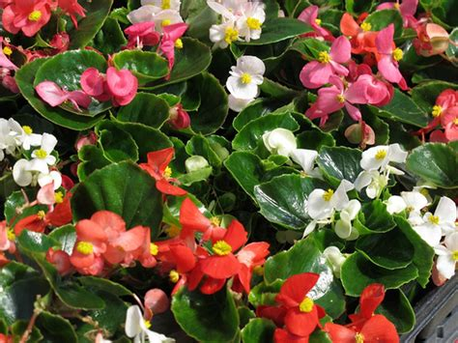
Impatients – Blue Pearl - 6 pack | High resistance to the currently known and widely prevalent populations of Plasmopara obducens, which causes Impatiens downy Mildew (IDM)  Spacing : 8-10"  Height : 14-18"  Width : 12-14"  Exposure : Shade, Partial Sun  Shows many flowers in a traditional shade plant that is a low-maintenance, must-have plant for shade gardens. | 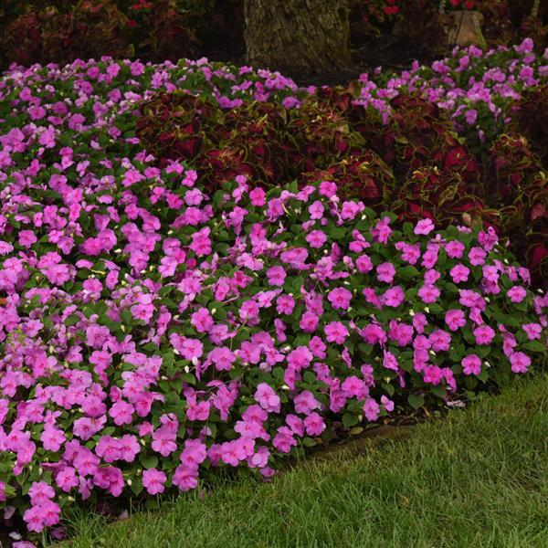
Impatients – Rosey Mix - 6 pack | • Height: 10-12 in  • Spread: 10-12 in  high degree of resistance to downy mildew.  Shade, Partial Sun  Beautiful and bountiful blooms, with proven landscape performance. Ideal as a shade bedding plant, but also does well in containers. Reliable flowering all season long, with great disease resistance. | 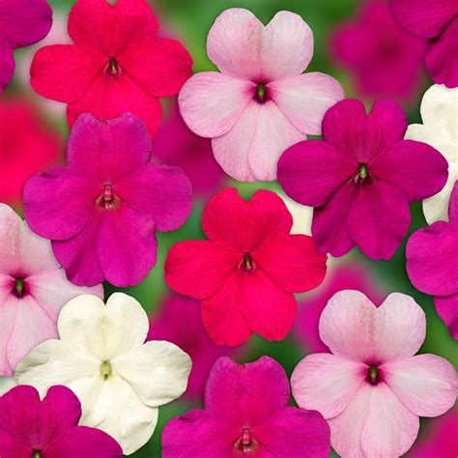
Salvia – Dwarf red- 6 pack | • Dazzling Red Blooms for Months: Summer Jewel Red produces an abundance of brilliant ½-inch red flowers that start in late spring and continue blooming until early fall, providing nonstop color and garden appeal.  • Compact and Uniform Growth: Reaching 20 inches tall and up to 16 inches wide, this dwarf salvia offers tidy, space-efficient structure for beds, borders, or containers without sacrificing bloom power.  • Pollinator Magnet: Loved by hummingbirds, butterflies, and bees, this variety helps support local ecosystems while turning your garden into a vibrant, buzzing pollinator haven.  • Tolerant of Heat and Dry Conditions: Adapted to summer stress, Summer Jewel Red performs well in hot, dry climates and blooms reliably in full sun with well-draining soil and moderate watering.  • | 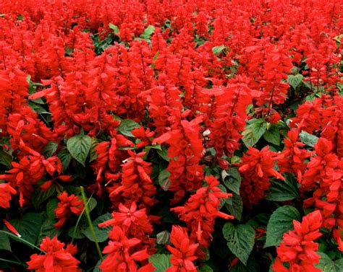
Nicotina – Lime Green - 6 pack | Plants have luminous flowers, which often open in the evening for many weeks during the summer and into fall. Grow in average, well-drained soil.  Absolutely intoxicating fragrance is released into the evening air at dusk and continuing into the morning hours.  Full sun to part shade | 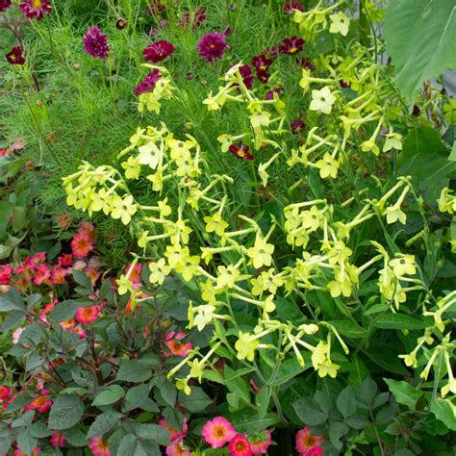
  Mature Height: 24" | Spacing: 10"
Cosmos – Sonata Mix - 6 pack | Sonata offers excellent branching, a uniform habit and large, attractive blooms. Not only do these varieties perform well in the garden, but because of their dwarf nature, they are excellent items for patio plants and color bowls.  • Plant Spread: 12-14"  • Plant Height: 18-24'' | 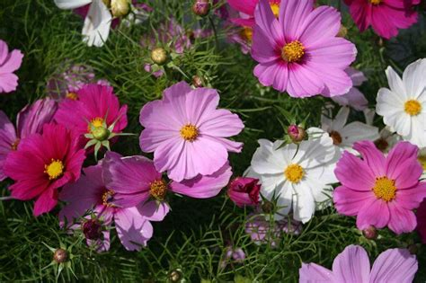
Zinnia – California Giant Mix - 6 pack | These enormous California Giant Zinnias come in a stunning mix of pink, purple, red, orange, white, and yellow. This easy-to-grow annual blooms all summer long, and will attract butterflies to your yard and garden.  - 4-5 in. semi-double flowers  - Mix of pink, purple, red, orange, white & yellow  - Grows 30-40 in. tall  - Attracts bees and butterflies  - Blooms from summer to frost | 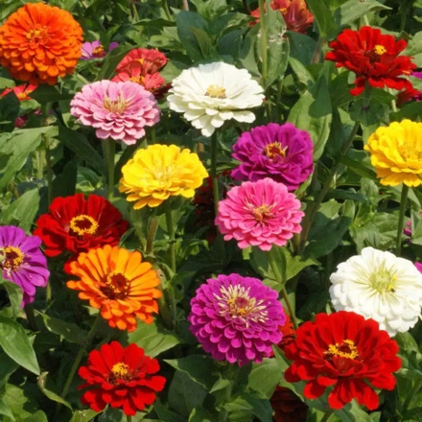
Calibrachoa Cabernet Blue - quart pot | Spacing: 8 – 12” Height: 6 – 10” Width: 10 – 12” A beautiful trailing variety that produces boldly colored blooms that blanket green foliage; perfect for patio containers, hanging baskets and garden landscapes; heat tolerant and self cleaning-no deadheading needed; attracts pollinators. | 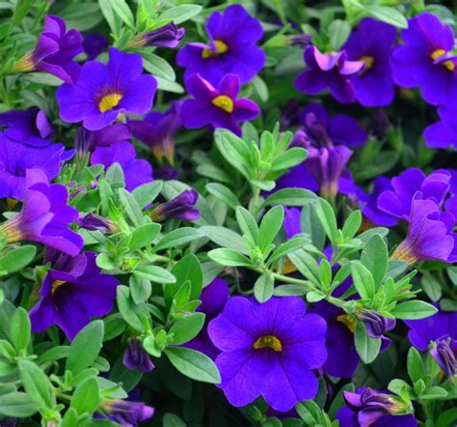
Calibrachoa Cabernet good night - - quart pot | Cabaret® Good Night Kiss Calibrachoa is a dense herbaceous annual with a trailing habit of growth, eventually spilling over the edges of hanging baskets and containers. Its medium texture blends into the garden, but can always be balanced by a couple of finer or coarser plants for an effective composition.This plant will require occasional maintenance and upkeep. Trim off the flower heads after they fade and die to encourage more blooms late into the season. It is a good choice for attracting bees and hummingbirds to your yard, but is not particularly attractive to deer who tend to leave it alone in favor of tastier treats. It has no significant negative characteristics. | 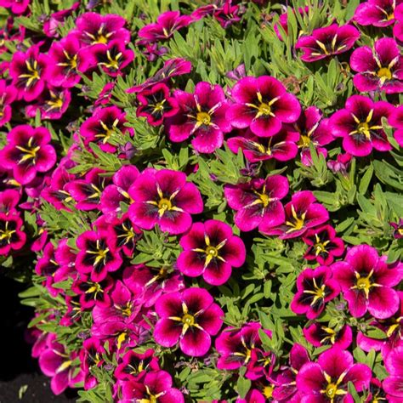
Calibrachoa Cabernet Orange - - quart pot | The 'Orange' variety of Cabaret® Calibrachoa grows best in full sun to partial shade.  This spring plant will grow to be 6 to 10 inches high, and will spread approximately 10 to 12 inches when fully matured.  A beautiful trailing variety that produces boldly colored blooms that blanket green foliage; perfect for patio containers, hanging baskets and garden landscapes; heat tolerant and self cleaning-no deadheading needed; attracts pollinators | 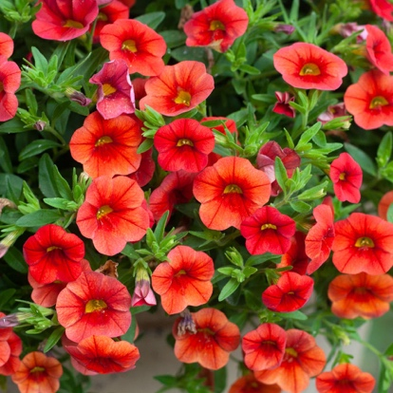
Geranium – Red - - quart pot | Full sun is best, especially for strong blooms.  Remove spent blooms to keep flowers coming.  Best use: Pots, window boxes, hanging baskets, borders, porch planters, and patriotic red, white, and blue displays. | 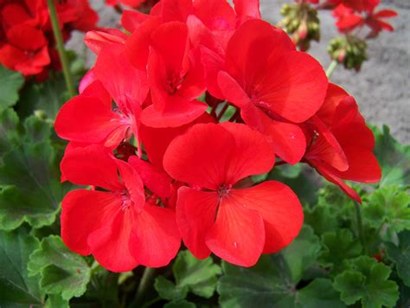
Geranium – Pink- - quart pot | Full sun is best, especially for strong blooms.  Remove spent blooms to keep flowers coming.  Best use: Pots, window boxes, hanging baskets, borders, porch planters. | 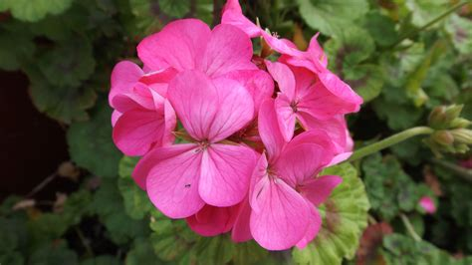
Geranium – White - - quart pot | Full sun is best, especially for strong blooms.  Remove spent blooms to keep flowers coming.  Best use: Pots, window boxes, hanging baskets, borders, porch planters. | 