Latin Name | Common Name | Size | Bloom Time | Bloom Color | Light | Moisture | Maintenance | Use | Culture | Picture
Agastache foeniculum | Anise hyssop | 2’-4’ x 1’-2’ | Summer into fall | Lavender/purple | Full sun to part shade | Dry to average | Easy | Rain garden, meadow, massing, perennial borders | Attracts: bees, butterflies  Birds eat seeds  Prolific self-sower  Companions: Echinaceas, Monarda, Liatris, | 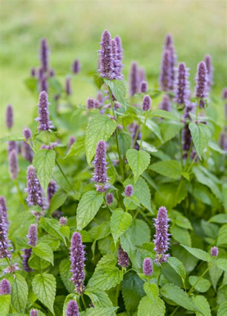
Allium cernum | Nodding Wild onion | 1’-1.5’ | June-August | Pink | Full sun-part shade | Dry to medium, poor soil best | Easy | Rock garden, native plant gardens, sunny border, prairie restoration, meadows | Attracts: bees, hummingbirds  Edible: use like chives  Companions: Eragrostis spectabilis, Schizachyrium, Rudbeckis, Sporobolus heterolepis, Asclepias tuberosa, Penstemon, Solidago flexicaulis, Carex | 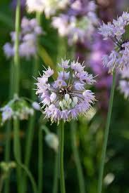
Amsonia hubrichtii | Threadleaf bluestar | 3’ | Late spring, early summer | Blue (fall foliage is gold) | Full sun, part shade | Dry, average, moist | Easy | Prairie style gardens, massed, sunny borders, cottage gardens, native plant gardens | Attracts: hummingbirds, butterflies, bees  Companions: Echinacea, Achillea, Rudbeckia, Schizyrachrium, Panicums | 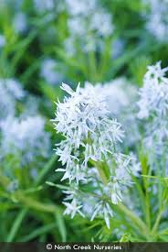
Aruncus dioicus | goat's beard | Height: 4.00 to 6.00 feet  Spread: 2.00 to 4.00 feet | April to May | Cream | Full sun to part shade | Medium to wet | Low | Rabbit | Best grown in moist, fertile, organically rich soils in full sun to part shade. Foliage decline can occur rapidly if soils are permitted to dry out. With consistent moisture, it performs well in full sun in the northern portions of its growing range. It prefers part shade in the southern part of its growing range. Removing faded flower stalks will not prolong bloom, but may improve plant appearance, particularly if a ground cover look is desired. On the other hand, flower stalks on female plants may be left in place to enjoy the continuing ornamental effect of the dried seed plumes. Plants can be slow to establish. Plants may struggle in climates with hot humid summers. | 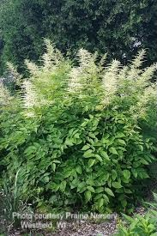
Asclepius tuberosa | butterfly weed | Height: 1.00 to 2.50 feet  Spread: 1.00 to 1.50 feet | June to August | Orange to yellow-orange | Full Sun | Dry to medium | Low | Deer, Drought, Erosion, Dry Soil, Shallow-Rocky Soil | Easily grown in average, dry to medium, well-drained soils in full sun. Drought tolerant. Does well in poor, dry soils. New growth tends to emerge late in the spring. Plants are easily grown from seed, but are somewhat slow to establish and may take 2-3 years to produce flowers. Mature plants may freely self-seed in the landscape if seed pods are not removed prior to splitting open. Butterfly weed does not transplant well due to its deep taproot, and is probably best left undisturbed once established. | 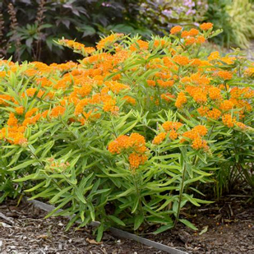
Conoclinium coelestinum | blue mistflower | Height: 1.50 to 3.00 feet  Spread: 1.50 to 3.00 fee | July to October | blue | Full sun to part shade | Medium | Medium |  | Easily grown in average, medium to wet, well-drained soils in full sun to part shade. Prefers moist, fertile, humusy soils which do not dry out. Mistflower is a vigorous plant that spreads aggressively by rhizomes and self-seeding. In some areas of the U.S., the species is considered to be a spreading weed. Propagate by clump division in early spring. Plants will grow in wet areas. Taller plants may be cut back in summer to prevent flopping | 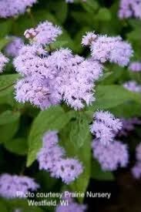
Echinacea pallida | pale purple coneflower | Height: 2.00 to 3.00 feet  Spread: 1.00 to 1.50 feet | June to July | Pale purple | Full sun to part shade | Dry to medium | Low | Deer, Drought, Clay Soil, Dry Soil, Shallow-Rocky Soil | Easily grown in average, dry to medium, well-drained soil in full sun to part shade. Best in full sun. An adaptable plant that is tolerant of drought, heat, humidity and poor soils. Divide clumps when they become overcrowded (about every 4 years). Plants usually rebloom without deadheading, however prompt removal of spent flowers improves general appearance. Consider leaving some seedheads standing as a winter food source for song birds. Freely self-seeds if at least some of the seed heads are left in place. | 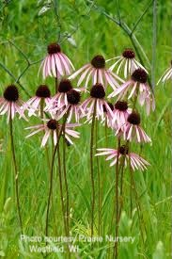
Echinacea purpurea | Purple coneflower | 2’-5’ | Summer into fall.  Deadheading prolongs bloom | Purple | Full sun, partial shade | Well-drained | Low | Borders, native gardens, meadows | Attracts: bees, butterflies, birds  Deer resistant  Readily self-sows  Leaving seed heads at the end of season provide food for birds, especially finches  Companions: Monarda, Rudbeckia, Penstemon, Baptisia, Pycnanthemum | 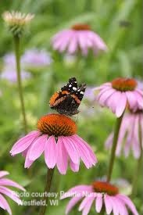
Echinacea purpurea | purple coneflower | 2’ – 5’ | June - august | Purplish pink | Full sun – part shade | Dry – medium | Low | Deer, Drought, Clay Soil, Dry Soil, Shallow-Rocky Soil |  | 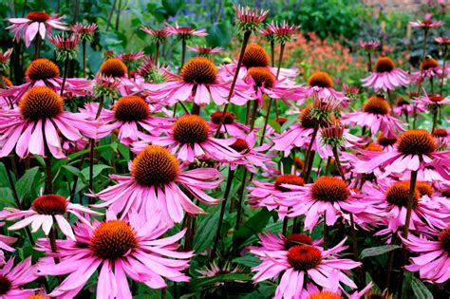
Eryogonum allenii | Shale barrens buckwheat | 16” x 16” | Late June to frost | Chrome yellow fading to bronze | Full sun | Dry, fast draining.  Prefers poor soil | Low | “Hell strip”, rock gardens, xeric gardens, dry clopes, rooftop gardens | Cold hardy  Grey-green fuzzy leaves turn shades of burgundy in fall,  Drought tolerant  Pollinator magnet  Deer/rabbit resistant  Companions: Bouteloua gracillis, Asclepias tuberosa, Amorpha canescens, Monarda punctata, Ruellia humilis, Liatris, Penstemon, Schizyrachrium | 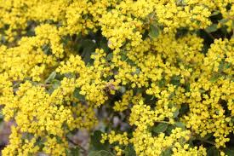
Fragaria virginiana | Woodland strawberry | 4” – 8” | April-May | White followed by red fruit | Full sun-part shade | Medium | Easy | Ground cover, lawn substitute, naturalize | Attracts: early pollinators, birds (larval host and berries)  Spreads by runners,  Companions: Assarum canadense, Symphyotrichums, Asclepias tuberosa | 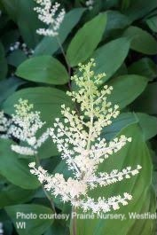
Helianthus divaricatus | Woodland sunflower | Size: 2'-6' | July, August, Sept. | Yellow | Part sun-part shade | Dry – Wet | Low |  | Partially shaded border, wild or native plant garden, or naturalized planting. | 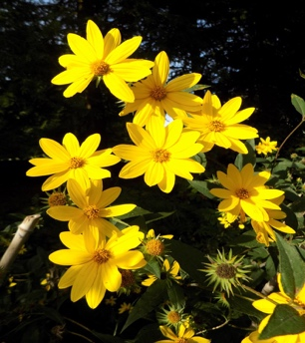
Liatris spicata | Dense Blazing Star | 2’ – 4’ | July – August | Deep purple - Dark lavender | Full sun | Medium | Low - leave seed heads for birds | Rain garden, prairie garden, perennial border, meadow, cut flower. Provides vertical contrast in the border | Attracts: birds, hummingbirds, butterflies  Tolerates poor soil, drought  Readily self-sows  Companions: Echinacea purpurea, Rudbeckia, Solidagos, Panicum virgatum, Sporobolus heterolepis
Lobelia cardinalis | Cardinal flower | 2’-5’ | July – September | Red | Sun, part sun, part shade | Moist to wet | Easy, | Pond and stream margins, perennial beds, wild gardens, butterfly gardens | Attracts: hummingbirds, small pollinators  Propogation from offsets of mother plant or by seed  Companions: Aruncus dioicus, Rudbeckia hirta, Loberlia siphilitica, Iris versicolor, sedges | 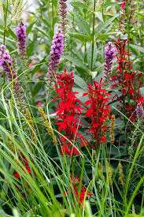
Maianthemum canadense | Canada mayflower | 3” – 6” | May-June | White, followed by berries | Part shade to shade | average | none | Ground cover, naturalize, shade garden | Attracts: early pollinators, birds and small mammals eat the berries  Soil stabilizer on slopes, grows under trees  Companions: Assarum canadense, Tiarella cordifolia, Sanguinaria | 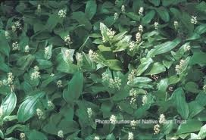
Monarda didyma | Scarlet beebalm | 2’ – 4’ | Summer | Red | Sun- part shade | Average | Deadhead to prolong bloom | Pollinator gardens, perennial borders, containers, meadows, massing | Attracts hummingbirds, bees, butterflies, songbirds,  Larval host  Allow good air circulation to prevent powdery mildew  Companions: Echinaceas, Phlox, Agastache, Achillea | 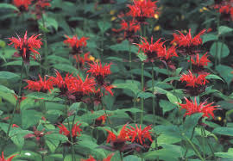
Monarda punctata | spotted beebalm | Height: 1.50 to 2.00 feet  Spread: 0.75 to 1.00 feet | June to July | Yellow with purple spot | Full sun to part shade | Dry to medium | medium | Deer, Drought | Easily grown in average, dry to medium moisture, well-drained soils in full sun to part shade. Best in full sun with sandy soils and consistent moisture. Tolerates somewhat poor soils and drought. Remove spent flowers to improve plant appearance and possibly to prolong bloom. Spreads by runners to form large clumps, but is not considered to be too aggressive. | 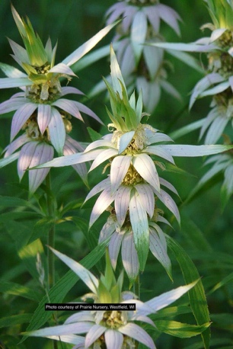
Packera obovata | Round-leaved ragwort | 1’-1.5’ x 0.5-1’  Spreading freely | April – June | Yellow. Stays green, underside of leaves are deep purple in early spring | Full sun- part shade | Medium to wet | Low. Spent flowers can be back(optional) | Ground cover, naturalize, rain garden, cottage garden, stream or pond sites | Not recommended for small spaces – spreads freely but does not affect other plants which grow up into it  Attracts: bullterflies  Deer/rabbit resistant  Companions: Ziziaa urea, Phlox divaricate, Aquilegia canadense, Iris cristata, ferns | 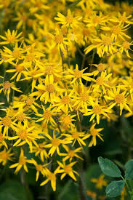
Penstemon digitalis | Floxglove beardtongue | Height: 3.00 to 5.00 feet  Spread: 1.50 to 2.00 feet | April to June | White | Full Sun | Dry to medium | Medium | Deer, Drought, Clay Soil, Dry Soil | Best grown in average, dry to medium moisture, well-drained soil in full sun. Tolerant of occasional drought and inundation once established. Can be grown in clay soils but avoid overly wet, poorly drained conditions. | 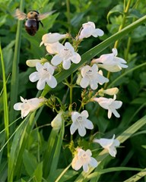
Penstemon hirsutus | Hairy beardstongue | Height: 1-2 feet | May to June | Lavender | Full, Partial, Shade | medium-wet to dry soils |  |  | Hairy beardtongue does best in a thin, well-drained, usually dry soil and will tolerate full sun to partial shade. If grown in the garden, you can use mulch to control weeds, and cut the spent flower stems back after blooming. It does self-seed but does not spread aggressively. | 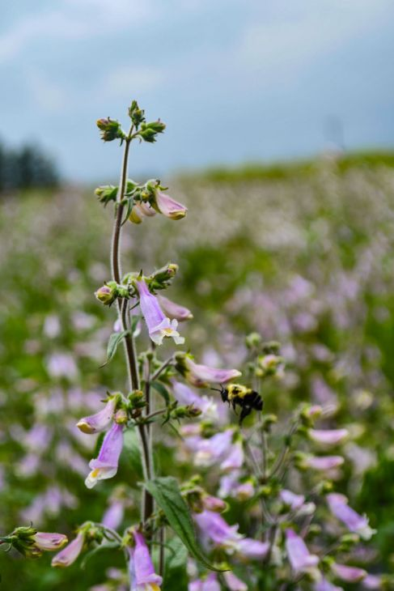
Phlox divaricata | Woodland phlox | 10”-14” spreading | Mid-late spring  Long bloom time | Blue | Part shade to shade | Average | None | Groundcover, woodland garden, naturalize | Attracts: bees, butterflies, larval host  Companions: Iris cristata, Tiarella cordifolia, Aquilegia canadense, Heucheras, carexes | 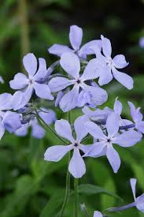
Pycnanthemum muticum | Clustered mountain mint | 2’ – 3’ | July – sept | White | Full sun – part shade | Medium – medium dry | Low | Pollinator powerhouse |  | 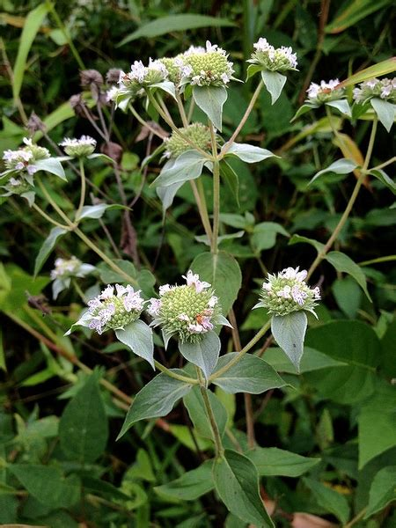
Ratibida pinnata | grey-head coneflower | Height: 3.00 to 5.00 feet  Spread: 1.50 to 2.00 feet | June to August | Yellow | Full sun | Medium | Medium | Drought, Clay Soil | Grow in average, medium moisture, well-drained soil in full sun. Prefers clay or sandy soils. Tolerates poor, dry soils | 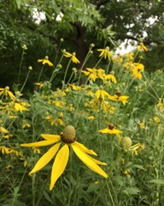
Solidago flexicaulis | broad leaf goldenrod | Height: 1.00 to 3.00 feet  Spread: 1.00 to 3.00 feet | July to September | Yellow | Full sun to part shade | Meium | Low | Heavy Shade, Clay Soil | Easily grown in average, medium moisture, well-drained soils in full sun to part shade. This is a woodland species that perhaps does best in sun-dappled part shade, but will also grow in full shade. Established plants tolerate some dry soils. Plants may be grown from seed and may self-seed in the garden. Plants may spread by rhizomes. | 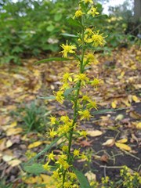
Symphyotricum novae-angliae | New England Aster | 3’ – 6’ (can be cut back in early summer to control height) | Late summer to early fall | Deep purple, lavender | Full sun | Medium | Low | Naturalize, rain garden, meadow, native plant garden, perennial border | Attracts: butterflies, long tongue bees, larval hose  Cover the loss of llower eaves that naturally dry up as the plant blooms with lower growing plants  Companions: Goldenrods, Asclepias incarnata, Rudbeckia, Monarda punctata, Liatris, Schizachyrium, Panicum virgatum, Andropogon | 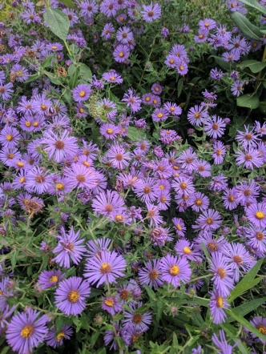
Tiarella cordifolia | Running Tapestry | Size: 10-12" | April – May | White | Part Shade - Shade | Medium - wet | Low | Groundcover, deer resistant | Ground cover under trees | 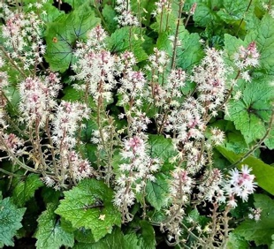
Zizia aurea | golden Alexander | Height: 1.50 to 3.00 feet  Spread: 1.50 to 2.00 feet | May to June | Yellow | Full sun to part shade | Medium | Medium | Clay Soil | Best grown in average, medium moisture, well-drained soils in full sun to part shade. Tolerant of a wide range of soils including clay, sandy and rocky. | 